Menu Screenshots:
The running Menu
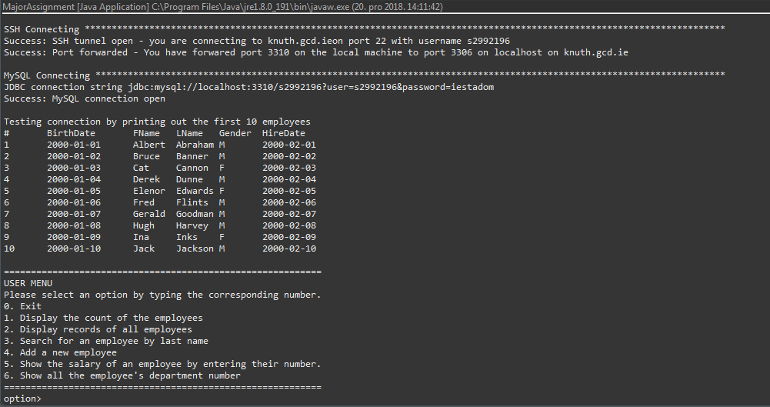

Option 1: Display the count of the customers
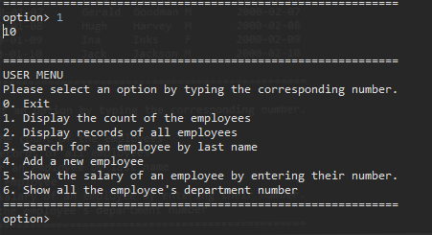

Option 2: Display records of all customers
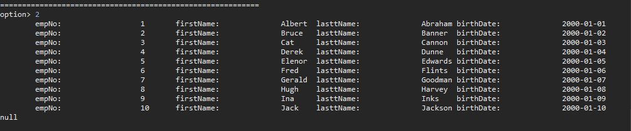

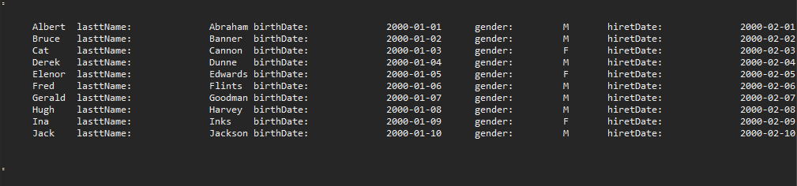

Option 3: Add a new customers (Input screen, with values input)
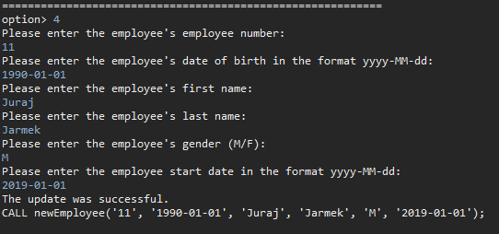

Option 3: Add a new customers (Output screen)

Run option 2 again after Option 3 has been run, (option 2, output):
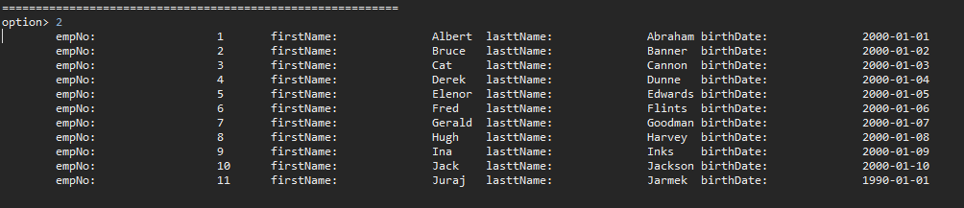

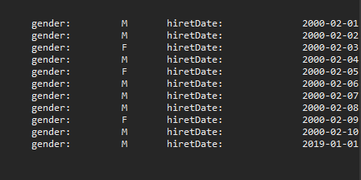

Option 4: Search for a customer by last name (Input & output)

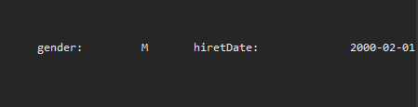

Option 5: To be added by Student (Input & output)
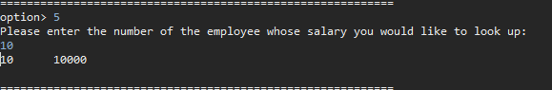

Option 6: To be added by Student (Input & Output)
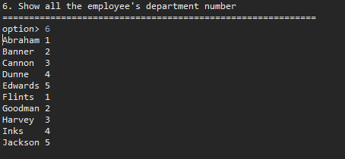

Additional Screenshot A (if necessary):
